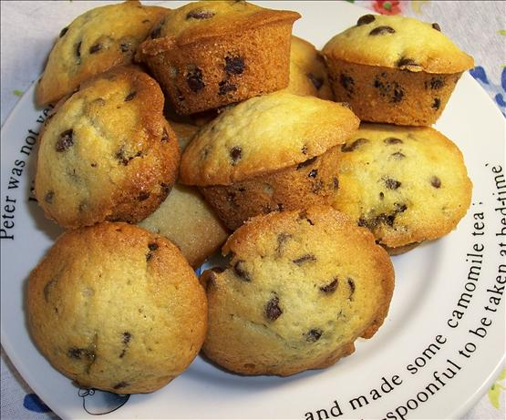
Chocolate Chip Muffins

Ingredients: completing
- 3 cups all-purpose flour
- 4 teaspoons baking powder
- 1 teaspoon salt
- 1 teaspoon ground cinnamon
- 1/4 teaspoon ground nutmeg
- 2 eggs, room temperature preferred
- 1 cup sugar
- 1 cup milk*
- 1/2 cup vegetable oil
- 1/2 teaspoon vanilla extract
- 1 and 1/4 cups semi-sweet chocolate chips (or chocolate chunks; or dark chocolate; or milk chocolate or mini-chocolate chips)
- coarse sugar for sprinkling (optional)

Directions:
Preheat oven to 375F degrees. Spray your muffin tin of choice with non-stick spray or line with muffin liners. Set aside.
In a large bowl, gently toss together flour, baking powder, salt, cinnamon, and nutmeg. Mix until all dry ingredients are combined – a 20 second toss to disburse everything together. Set aside.
In a medium bowl, whisk together eggs and sugar until combined. Mix in milk, oil, and vanilla. Mixture will be pale and yellow. Fold wet ingredients into dry ingredients and mix everything together by hand with a wooden spoon. Avoid overmixing. Gently mix until all the flour is off the bottom of the bowl and no big pockets of flour remain. The batter will be VERY thick and somewhat lumpy. Fold in the chocolate chips.
Pour batter into prepared muffin tins, filling all the way to the top. Top with a sprinkle coarse sugar, if preferred. Bake at 425F degrees for 5 minutes. Reduce oven temperature to 375 and continue to bake for 25-26 minutes until tops are lightly golden and centers appear set.
Allow to cool for 10 minutes in pan before enjoying. Muffins taste best fresh the same day. Store muffins at room temperature in an airtight container for up to 5 days. Muffins freeze well, up to 3 months.
For mini muffins, bake for 12-13 minutes at 375F the entire time.

